**Word with embedded objects Sample**

1. **Embedded ZIP with an executable inside it:**



1. **Embedded Script File:**



1. **Embedded inline image:**

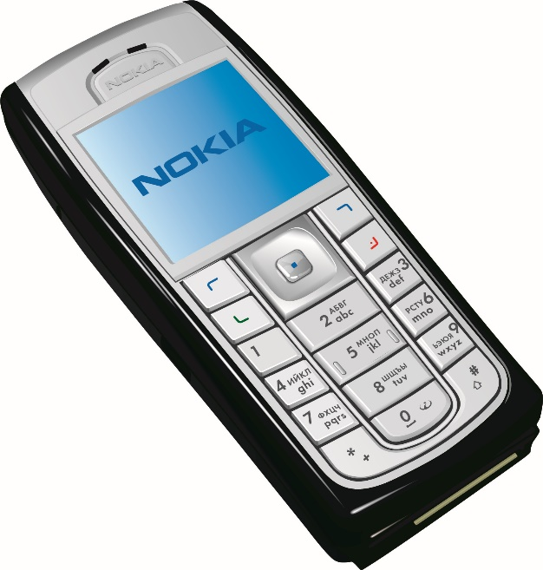

1. **Embedded OLE object (PowerPoint) type 1:**

